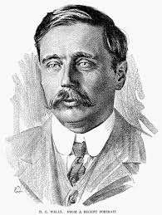

**Autumn Term 2024**

**Welcome to Year 3 & 4 - Wells**

Hi from all in Wells,

This letter is designed to offer those of you at home some general helpful information about the upcoming Autumn term. Should you have any further specific queries you are, of course, always welcome to contact the office to book an appointment to arrange to speak with us. Or if it’s a quick question, simply pop over and ask at collection on the playground.

**Useful class pencil case equipment list**

* Clear 30cm Ruler (not flexible)
* Several HB pencils and colouring pencils
* Eraser
* Pencil Sharpener
* Scissors & Glue Stick

**Intended Learning**

To help support your child’s non-fiction reading, here are some of our topics for the Autumn term:

|  |  |
| --- | --- |
| **Subject** | **Area of focus** |
| **Literacy** | We develop our writing skills through focusing on a variety of specific texts which ensure we explore a range to genres. To start the year, we are looking at the book **‘Journey’** by Aaron Becker. |
| **Maths** | **Place value,**  **Addition & Subtraction,**  **Multiplication & Division** |
| **Science** | **Food and Our Bodies**: Nutrition, muscles and bones.  **Rocks, soils and fossils:** Grouping, physical/properties, forming fossils, how rocks are made |
| **Computing** | **Connecting computers**  Identifying that digital devices have inputs, processes, and outputs, and how devices can be connected to make networked  **Branching databases**  Building and using branching databases to group objects using yes/no questions. |
| **Geography** | **World Trade:** How does global trade affect people and places? |
| **History** | **Stone Age to Iron Age:** How did Britain change during these periods |
| **R.E.** | **Creation:** What do Christians learn from the creation story?  **Incarnation:** What is the Trinity? |
| **Design and Technology** | **Food:** healthy and varied diet |
| **Art** | **Drawing:** Gestural Drawing using charcoal |

**Games & P.E.**

**Our PE / Games sessions are on Thursday afternoons. Please can all sports wear & uniform be clearly named.** Your child should have for PE a plain t-shirt and shorts, trainers or plimsolls.

**Our Class Timetable**

A typical class week for us looks like this, though it is necessarily flexible:

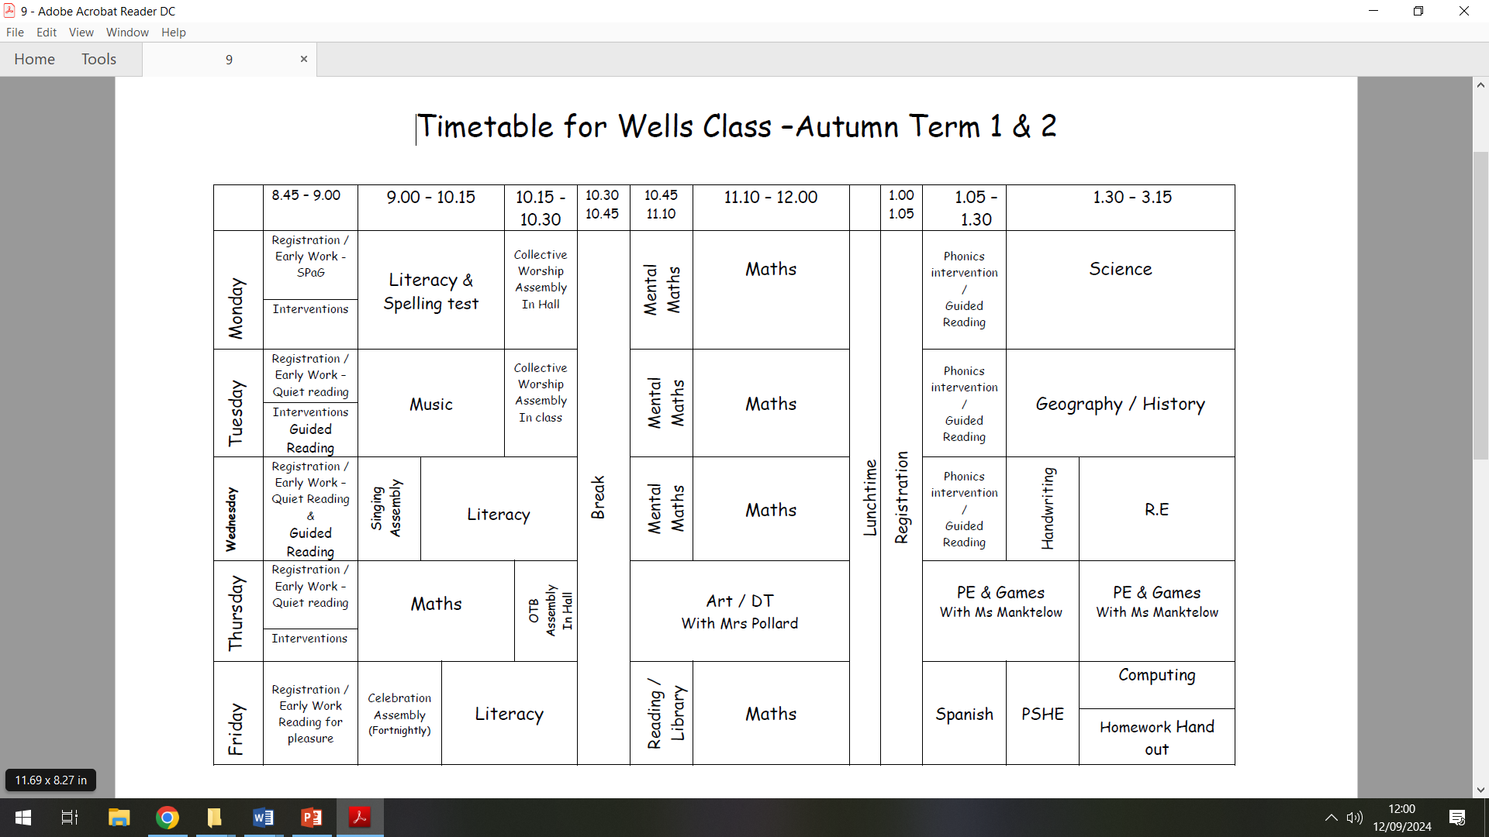

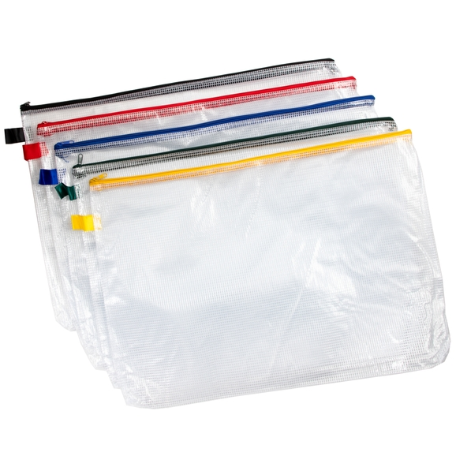

A homework pack will be set and sent home on **Fridays.**

The homework pack should be returned to school every **Wednesday.**

It should always come home to you inside a named zipped plastic folder.

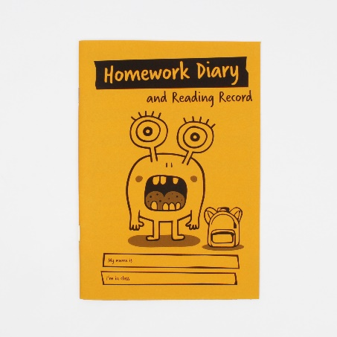Inside your child’s folder should be a yellow reading homework diary/reading record. Inside this homework diary there is a page

for you to please record any opportunities when you can hear

your child read. Please can this diary stay with the zipped folder.

Also, inside the homework diary there is a page where we will

attach weekly spelling and any information about further

homework tasks.

**Spellings**

The weekly spellings are split into the 2 year-groups though both sets have a similar area of focus. They come home inside the diary on a Friday in advance of us starting to look at them on the Monday in class. Throughout the following week we use opportunities to go over these spellings. Any additional opportunities to practice at home help support the retention of these words. Year 4 children ideally should be aiming to be secure spelling both groups of words. Spellings are then checked the following Monday. Year 3 children can challenge themselves to learn the Year 4 words alongside their own.

**Maths**

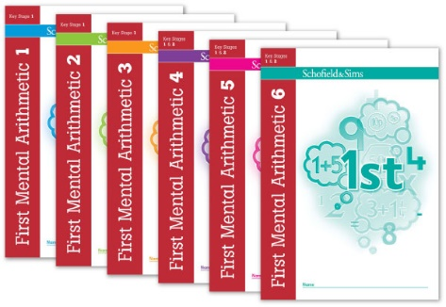 Recently, all children across the school completed an assessment for starting the Schofield & Sims Mental Arithmetic books. Their individual results have informed us which book they should start on or continue with. We will continue to review each child’s progress during the year.

* Please ONLY aim to complete one session in pencil each week. This is normally no more than 30 questions, so you could do a few questions each day.
* Please complete all homework in pencil.
* Return the books on **Wednesday** inside their protective plastic covers along with their pink books.
* Please check each of the sections (A, B, C) in the session with your child. (Feel free to make comments on methods and understanding as well as celebrating the successes.
* These homework books come home on Fridays

**Reading**

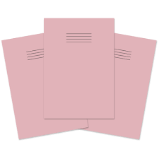Please can the children be encouraged to read regularly for at least 20 minutes every day. This could be reading to an adult aloud. Alternatively, independent reading followed by discussing the pages they have read to develop their comprehension and understanding. Or sharing a book whilst reading together. I cannot stress how important reading is. There are 5 sections for reading to be recorded inside the Homework diaries each week. We have a similar set of reading record books we use in class to note when we hear your children read during the week supported further by our amazing volunteer readers.

**The Pink book**

For homework based on a specific class topic and

additional Literacy tasks we will send home a Pink book.

Information about the set task can then be found stuck

inside the book.

**Healthy Snacks**

Throughout the day it is helpful if the children have with them a water bottle. There is a specific break time daily in the morning when children can (if they are able) have a healthy snack. During most of the afternoon sessions as we naturally transition from one subject to another we also permit an additional healthy snack break / refilling of water bottles mid-way through the afternoon.



We do hope that your child enjoys and gains maximum benefit from this important academic year. It is a noticeable step up into Year 3 / 4 from being in the lower half of the school. Don’t forget that the above information plus lots more is available on the Year 3 & 4 Wells section of the Frittenden Website.

We hope you had an enjoyable summer and we look forward to meeting you over the upcoming weeks.

Many thanks for your support

Mr Hancock & all the Year 3 / 4 team